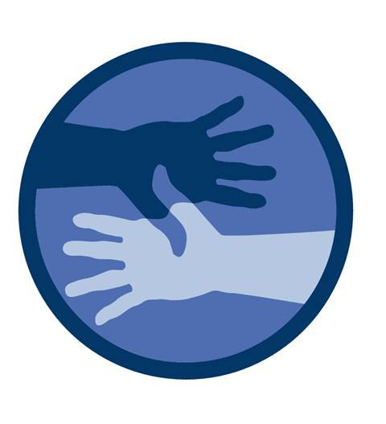
THE MULTICULTURAL HEALTH INSTITUTE
Presents

MHI
KNOW NO BOUNDS
SUMMER TECH SESSION
- Use Technology to learn about Science Technology Arts Mathematics Technology Health (STEAMH)
- Meet game designers and STEAMH leaders
- Learn how to create an app
- Meet new friends, have fun while learning
- Win prizes!
SIGN UP FOR SUMMER PROGRAM NOW!

Location: North Sarasota Library
2801 Newtown Blvd, Sarasota, FL 34234
3-5 PM Monday 7/24/17 to Friday 7/28/17
For more information and to sign up, call or contact
Call (916) 849-6231 or (941) 225-8198
E-mail: Ldeaninvest@comcast.net or MHIgtkpr@gmail.com
677 North Washington Blvd.
Sarasota, FL 34236
Tel: 941.225.8198
www.The-Mhi.org
In Partnership With
